Dear Ministry Partner,

APRIL 2021

This year is flying by. It seems like just yesterday we were celebrating the birth of our Savior, when in reality, we just celebrated His Resurrection. Praise the Lord for He is Risen!
As you may have seen or heard in the news, the U.S./Mexico border is in crisis and it is chaos. The U.S. is only allowing U.S. citizens to come back into the United States. This also means no Mexican citizens, despite having a passport, can come into the USA. Most goods are cheaper to buy in the states than in Mexico so we purchase everything here and take it across. We are also blessed to receive donations of food so that also needs to be crossed into Mexico. Pre-pandemic, we would have our staff and volunteers in Mexico come to our headquarters in El Paso and take goods over to Juarez. Well, with the government not allowing Mexican citizens to enter our country, we are having more difficulty getting things across. Another challenge we face is that U.S. Customs Agents have decreased the lines to come back into the US to only one line, so you are waiting in line for a very long time. The large groups of immigrants from other countries seeking asylum are lining up at the bridges creating even more disorder. All these things add up to major challenges for us as we continue ministering in Juarez. Please pray for us as we face these added challenges.

We are grateful that despite challenges, God is allowing us to serve 1,330 meals to hungry children and adults each day. We are currently housing 220 immigrants (141 adults and 79 children).
Dr. Soria and the medical staff saw and treated 926 patients at all our locations in the last 3 months. They are staying busy and staying safe while practicing all precautions. The Bible Institute has 9 students enrolled this term and we will have 2 students graduating next month.
The first quarter of 2021, we had 119 people that accepted Jesus Christ as their Personal Savior. Praise the Lord!!
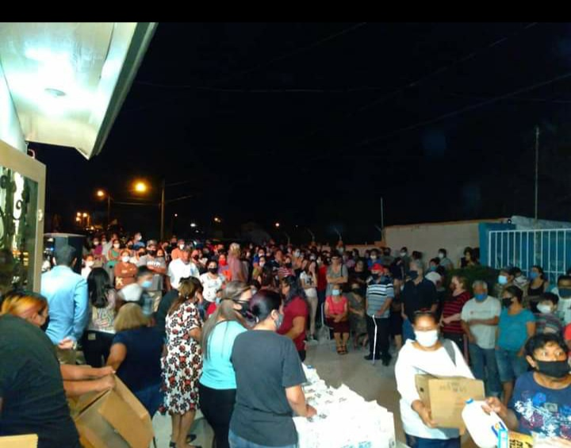
*the above photo is of people lined up to receive food that was donated to us. We receive more food than we can use up before it spoils so we share it with communities that are in need

Thank you for your prayers and support. We are grateful for what God continues to do! God bless you.

